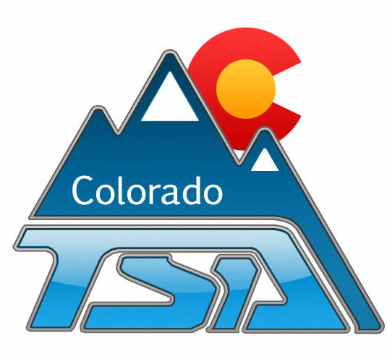
Meeting Minutes

*Your School Name* TSA
Month, Day, Year
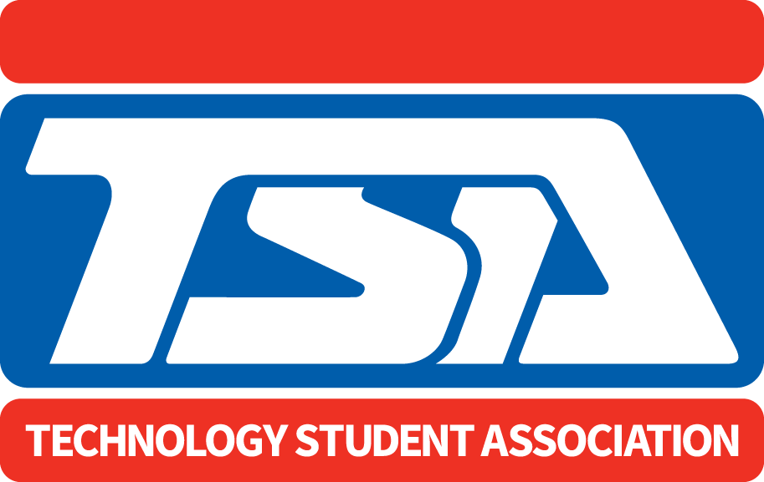

Agenda | Discussion | Action Items
- ROLL CALL | Present:  Tardy:
- APPROVAL OF THE MINUTES
- REPORTS OF OFFICERS AND COMMITTEES
- UNFINISHED BUSINESS AND GENERAL ORDERS
- NEW BUSINESS
- ANNOUNCEMENTS
- ADJOURNMENT

